Health and Safety News Item
November 2025 – Canopy/shelter loose fixings - What Happened
Following a recent site visit, a surveyor encountered an issue with the shelter / canopy at a Norfolk school. The issue was initially flagged up by a contractor who walked under an external shelter and found a fixing on the floor. On inspection it was found that a nut had become detached from the bolt that holds a steel strut in position. The bolt had also partially worked its way out of the steelwork and the section was close to failing. Upon further inspection it found that several other fixings were also loose. The failure of these parts could have resulted in the structures collapse.
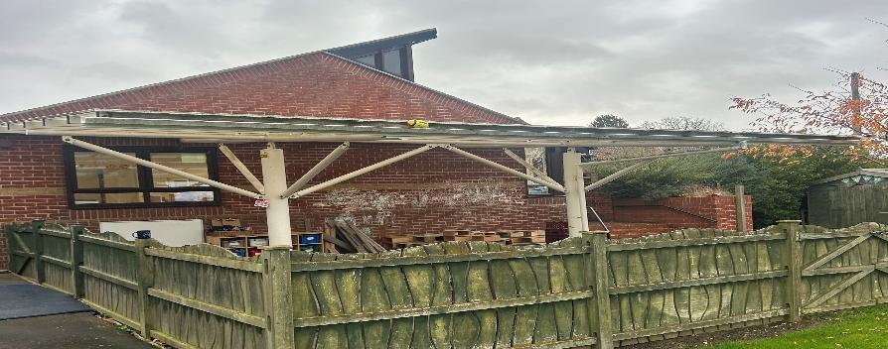

Health and Safety News Item
Photographs
- Bolt holding steel strut in place – bolt had worked loose from the structure.
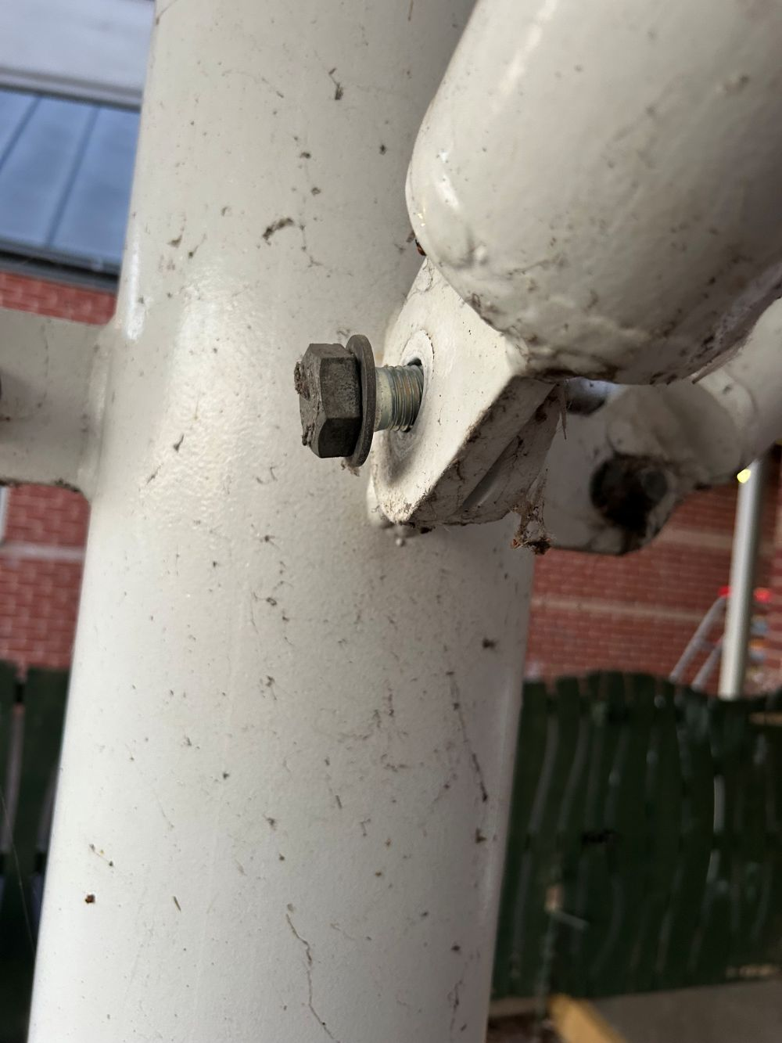

2. Nut side of fixing – nut is missing from bolt (found on floor under structure)
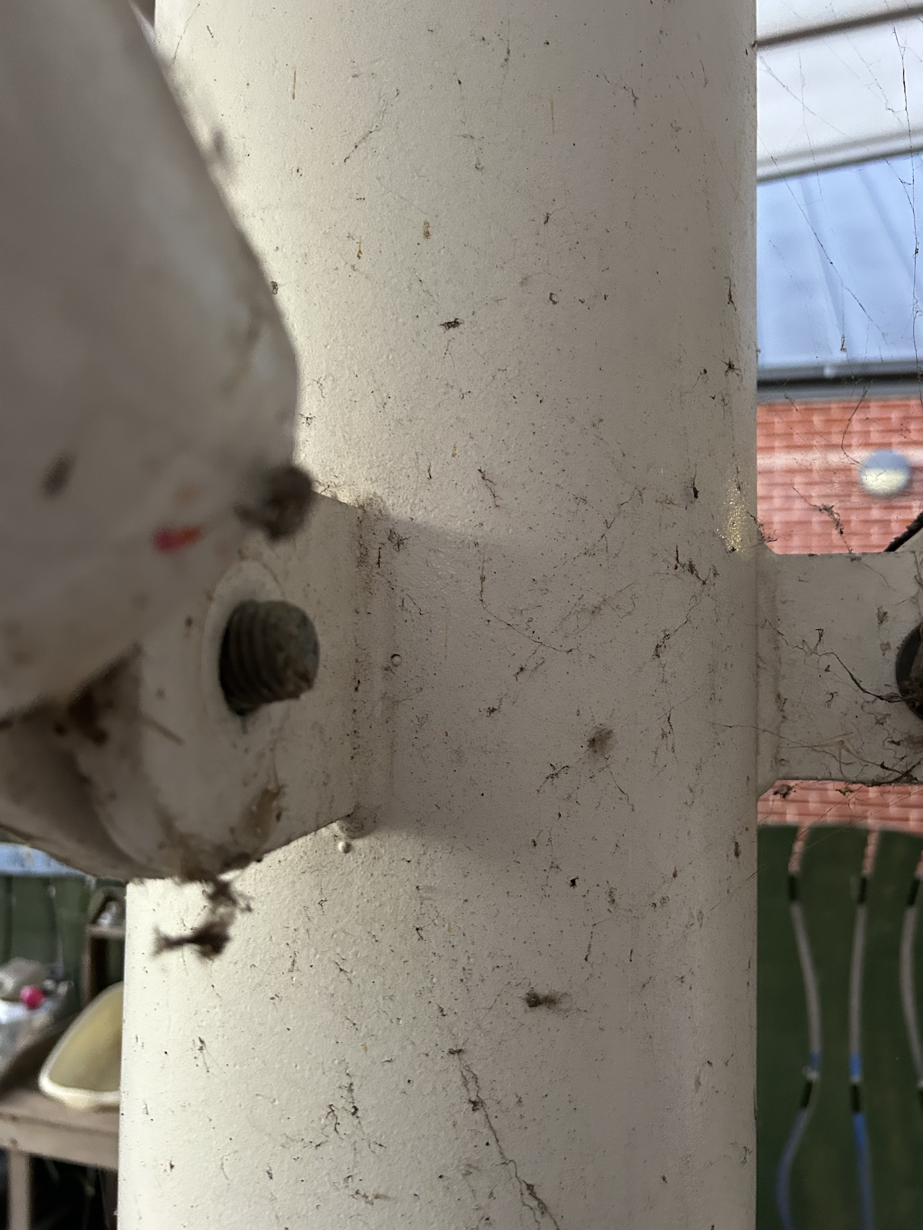

Health and Safety News Item
These canopy/shelters remain the responsibility of schools to check, maintain and repair. Please ensure someone with the relevant knowledge, skills and experience regularly checks the condition of such structures and completes necessary maintenance and repairs as and when required. The minimum inspection frequency is annually. However, it is also advised to inspect such structures following extreme weather events. The BMP6 scheme excludes shelters, pergolas and bandstands.
Action you need to take
Check
Physically inspect any structures that are not detailed (inspected) on your annual buildings inspection immediately for any signs of fixing failures.

Inspection
Arrange for the structures to be inspected by a competent person. This can be arranged through NPS/BMP or your designated facilities contractor.

Risk Assessments
Ensure that your premises risk assessment has been completed and that it covers:

- Annual inspection of the structures, to include visual inspection of the connecting strut fixing.
- Regular visual inspection of structures termly and after bad weather conditions and; that this is documented.

Contact
For more information contact your allocated NPS Building Surveyor or telephone the NPS helpdesk on 0808 1753067 or via email at helpdesk@nps.co.uk

